**Laboratory Project 3 - Frequency Modulation & Detection**

**Objectives**

This project has 4 parts:

* In Part 1, you will investigate the performance of the slope detector.  
* In Part 2, you will generate FM bandpass signals using the ICL8038 Precision Waveform Generator/Voltage Controlled Oscillator.   
* In Part 3, you will use the LM565 Phase-locked-loop for demodulating FM signals.

**Equipment and Software**

* Function Generator/Arbitrary Waveform Generator  
* RF Signal Generator.    
* Oscilloscope  
* 1N4148/914 Fast Switching Diode  
* ICL8038 Precision Waveform Generator/Voltage Controlled Oscillator.    
* LM565 Phase-locked-loop.    
* Modular Backplane  
* Slope Detector Module  
* Assorted Resistors and Capacitors (based on design)  
* PC speakers  
* Audio Player/PC  
* CD or current media format with your favorite legally acquired music!  
* MATLAB (with Instrument Control Toolbox)  
* MATLAB Connectivity Functions:

**Part 1**

Project Requirements

* Design the slope detector circuit shown in Figure 1. The slope detector is nothing but a frequency-to-voltage converter followed by an AM envelope detector.The design equation for the frequency-to-amplitude converter is given by:

http://users.rowan.edu/~mease/courses/ecommss12/images/lab2_eq_lpf.gif

fco is chosen to be at the carrier frequency of the FM signal. The design equation for the envelope detector circuit is similar and was provided in Lab Project 2. As before, C3 is a coupling capacitor, chosen such that C3 >> C2 . As part of your initial design parameters, you can choose an FM carrier frequency of 30kHz and a maximum modulating frequency of 15kHz to design your circuit.

**[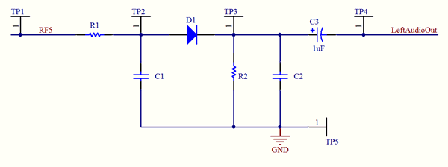](http://users.rowan.edu/~mease/courses/ecommss12/images/SlopeDetector.gif)**  
Figure 1: Slope detector circuit.

* Using the HP Arb. Function Generator, generate an FM wave with carrier frequency of 30kHz and modulation frequency 1kHz (single tone).

- Vary the frequency deviation and observe the input and output waveforms.  
- Vary the modulating frequency and observe the input and output waveforms.  
- Determine the range of performance of the slope detector, in terms of modulation frequency and modulation index.  
- Digitally capture samples of the input and output waveforms in this range  
- Perform a spectral analysis of these input and output waveforms.

* At each stage, note your obervations and conclusions.

**Part 2**

The objective in Part 2 is to generate single- and multi-tone FM signals using a voltage controlled oscillator and observe the waveforms in the time and spectral domains.

* Implement the Frequency Modulator circuit shown in the data sheet (reproduced in Figure 2 below). The output of the VCO when no modulation is applied (i.e. the carrier frequency) is given by f = 0.33/RC, where R = RA = RB = RL. Design the circuit for a carrier frequency of 30 kHz. Test the system response by feeding a 1Hz audio-frequency tone to the FM sweep input pin. Observe the waveforms on the oscilloscope.

**[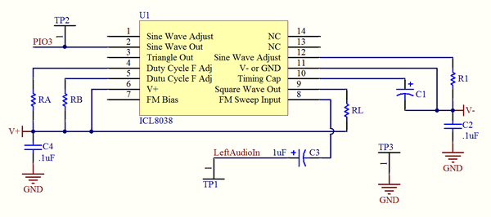](http://users.rowan.edu/~mease/courses/ecommss12/images/LF_FMModulator.gif)**  
Figure 2: Frequency modulation application circuit from ICL8038 data-sheet.

* Experiment with varying the modulating signal frequency and amplitude. Oberve the input and output waveforms.

* Determine the range of modulation indices and modulating frequencies at which this circuit will operate. Digitally capture a few input/output waveforms in this range and perform spectral analysis. Confirm your obervations with theoretical predictions.

* Experiment with feeding in multi-tone modulating signals at the modulating signal input of this circuit.

* Use the slope detector circuit you have designed in Part 1 to recover the baseband signal (for both single- and multi-tone). Observe and listen.

**Part 3**

The objective in Part 3 is to demodulate an FM signal using a voltage controlled oscillator and observe the waveforms in the time and spectral domains.

* Design the test circuit shown in Figure 3. Choose the free-running frequency of the Phase Locked Loop (PLL) equal to the carrier frequency of the FM signal. The design equation is f0 = 0.3/RC, where R = R1 + R2. C2 is coupling for the timing resistor. The value can be selected as 0.001uF. R3 and C3 form a simple LPF for the output (which we hope is your recovered message signal).

**[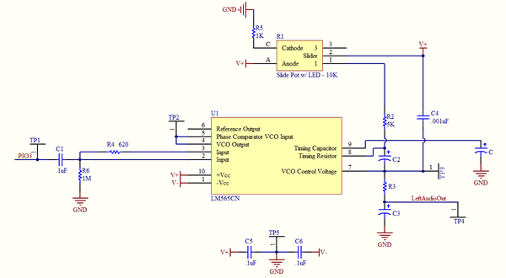](http://users.rowan.edu/~mease/courses/ecommss12/images/LF_FMDemodulator.gif)**  
Figure 3: FM demodulator circuit using the LM565 PLL.

* Use a 9V rail.

* Test the circuit by feeding in an FM signal from the arbitrary function generator, observe (waveform and spectrum) and listen to the audio output. Vary the input signal amplitude, the modulating signal frequency and the modulation index. Experiment with the capture range and lock range of the PLL.

* Test the product detector circuit by feeding digitally synthesized FM signals with varying SNR. When does the demodulator fail to detect the message signal?

* Link the modulator-demodulator circuits and observe signal progression from input to output. You will need to use an op-amp buffer circuit between the two circuits so that the demodulator does not overload the VCO output.

**Required Reading**

* Sections 4.13, 4.14 and 5.6 of textbook.  
These labs originally created by Dr. Shreekanth Mandayam & Dr. John Schmalzel.

**References:**

* Appendix B (p. 650) in textbook  
* Zsolt Papay, Technical University of Budapest (TUB),"Experiments in Gaussian White-noise Generation," HP Test and Measurements Educator's Corner,[**http://www.home.agilent.com/upload/cmc_upload/All/Exp65.pdf**](http://www.home.agilent.com/upload/cmc_upload/All/Exp65.pdf)  
* Chapter 4, 5 in the texbook.